1. **Least squares:**

The least squares method is based on the criterion of minimizing mean squared error. Let’s consider the 2-class case:

Let C0 and C1 denote the two classes. Thus, if y(i) = 0 then Xi ∈ C0 and if y(i) = 1 then Xi ∈ C1

Let n0 and n1 denote the number of examples(features) of each class. (n = n0 + n1)

For any W, y are the one-dimensional data that we get after projection.

$$y_{i}=w^{T}x_{i}$$

We now determine the parameter matrix $w$, by minimizing a sum-of-squares error function:

$E_{D}\left[w\right]=\frac{1}{2}T_{R}{\left(xw-T\right)}^{T}\left(xw-T\right)$

Setting the derivative with respect to $w$, to zero, and rearranging, we then obtain the  
solution for $w$, in the form:

$w$ = ${\left(x^{T}x\right)}^{-1}x^{T}T=x^{†}T$

where $x^{†}$ is the pseudo-inverse of the matrix x. We then obtain the discriminant function in the form.

**Following are the Confusion matrices for different datasets for both training**

**and test sets:**

1. **Wine Data**

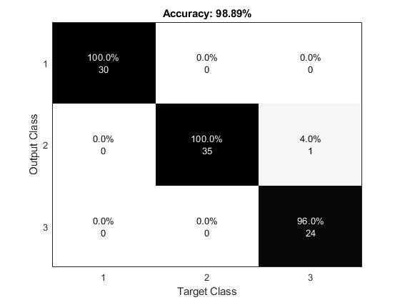

**Training Data Set**

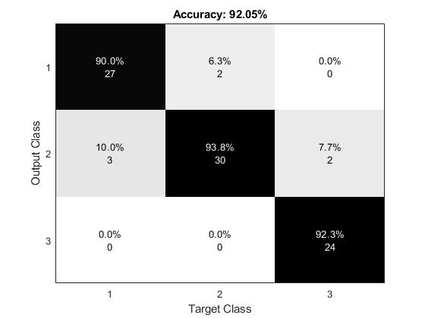

**Test Data Set**

1. **Wallpaper Data**

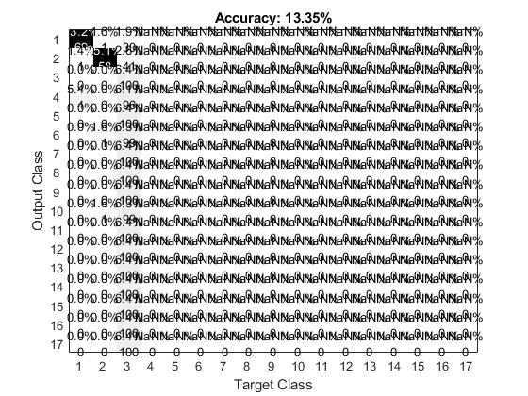

**Training Data Set**

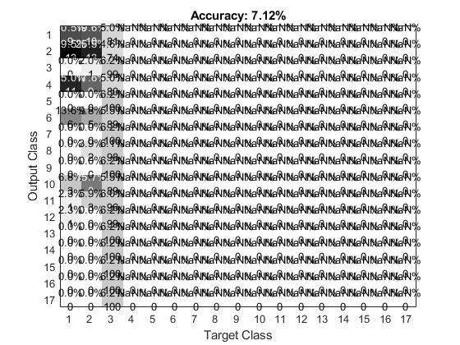

**Test Data Set**

1. **Taiji Data**

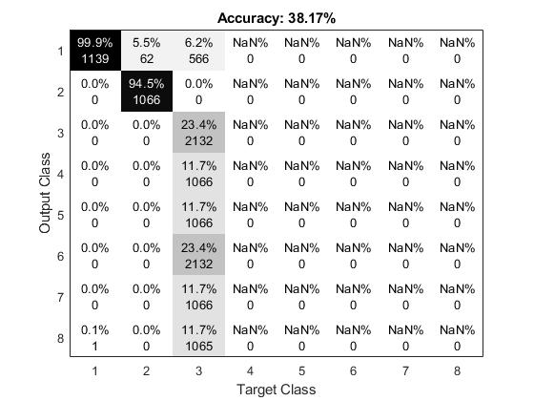

**Training Data Set**

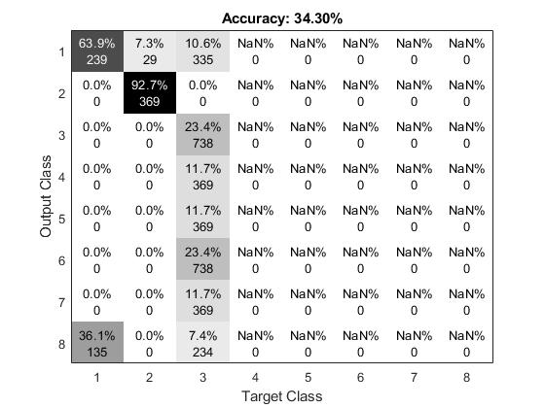

**Test Data Set**

Below is the 3-Dimensional figure for Wine testing:

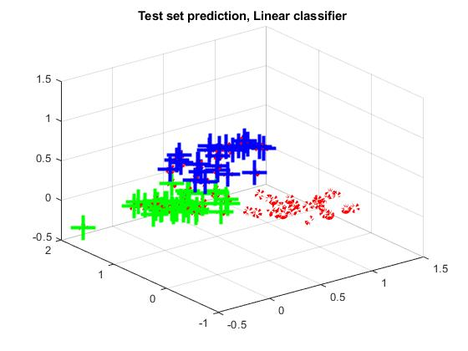

1. **Fisher LDA:**

The least squares method is based on the criterion of minimizing mean squared error. Let’s consider the 2-class case:

Let C0 and C1 denote the two classes. Thus, if y(i) = 0 then Xi ∈ C0 and if y(i) = 1 then Xi ∈ C1

Let n0 and n1 denote the number of examples(features) of each class. (n = n0 + n1)

For any W, z are the one-dimensional data that we get after projection.

$$z_{i}=w^{T}x_{i}$$

Let $M_{0}$ and $M_{1}$ be the means of data from the two classes:

$$M_{0}=\frac{1}{n_{0}}\sum_{⋅}{x_{i}}$$

$$M_{1}=\frac{1}{n_{1}}\sum_{⋅}{x_{i}}$$

we want a W that maximizes ${\left[m_{0}-m_{1}\right]}^{2}$

However, we have to make this scale independent.

Also, the distance between means should be viewed relative to the variances.

Thus, we define:

$s_{0}^{2}=\sum{(w^{T}x_{ⅈ}}-m_{0})^{2}$ $s_{1}^{2}=\sum{(w^{T}x_{ⅈ}}-m_{1})^{2}$

$x_{i}∈C_{0}$ $x_{i}∈C_{1}$

These give us the variances (upto a factor) of the two classes in the projected data.

We want large separation between $M_{0}$ and $M_{1}$ relative to the variances.

Hence, we can take our objective to be to maximize:

$$J_{w}=\frac{{\left(M_{1}-M_{0}\right)}^{2}}{s_{0}^{2}+s_{1}^{2}}$$

${\left(M_{1}-M_{0}\right)}^{2}$ = ${\left[w^{T}M_{1}-w^{T}M_{0}\right]}^{2}$

${\left(M_{1}-M_{0}\right)}^{2}$ = $W^{T}\left(M_{1}-M_{0}\right){\left(M_{1}-M_{0}\right)}^{T}W$

= $W^{T}S_{B} W$

$S_{B}$ = $\left(M_{1}-M_{0}\right){\left(M_{1}-M_{0}\right)}^{T}$

$S_{B}$ is a d × d matrix

We can similarly write $s_{0}^{2}$ and $s_{1}^{2}$ also as quadratic forms.

We know

$s_{0}^{2}=\sum{(w^{T}x_{ⅈ}}-m_{0})^{2}$ $s_{1}^{2}=\sum{(w^{T}x_{ⅈ}}-m_{1})^{2}$

$x_{i}∈C_{0}$ $x_{i}∈C_{1}$

$s_{0}^{2}+s_{1}^{2} =$ $W^{T}S_{w} W$

$S_{w}$ is also d × d matrix and is called within class scatter matrix

Thus,

$J_{w}$ = $\frac{W^{T}S_{B} W}{W^{T}S_{w} W}$

We want to find a W that maximizes $J_{w}$:

$J_{w}$ is not affected by scaling of W.

Maximizing ratio of quadratic forms is a standard optimization problem

Differentiating w.r.t. W and equating to zero, we get:

- * = 0

This Implies, $S_{B} W$ is in the same direction as $S_{w} W$

Thus, any maximizer of $J_{w}$ has to satisfy $S_{w} W$ = λ $S_{b} W$ for some constant λ

This is known as the generalized eigen value problem.

By solving the generalized eigen value problem we can find the best direction W.

**Following are the Confusion matrices for different datasets for both training and test sets:**

1. **Wine dataset:**

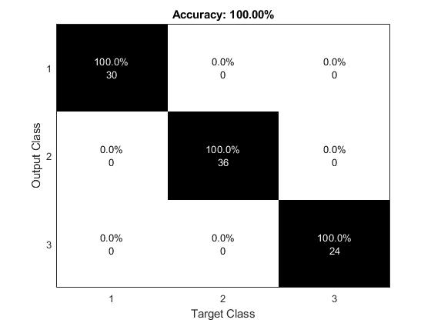

**Training Data Set**

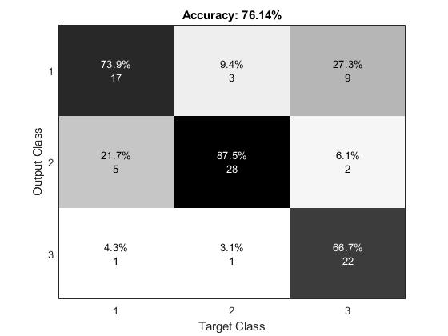

**Test Data Set**

**b. Wallpaper Data Set:**

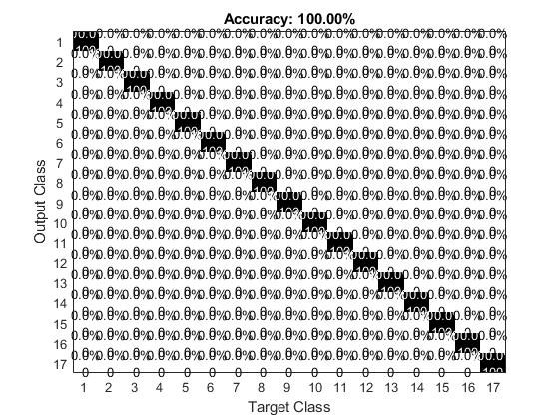

**Training Data Set**

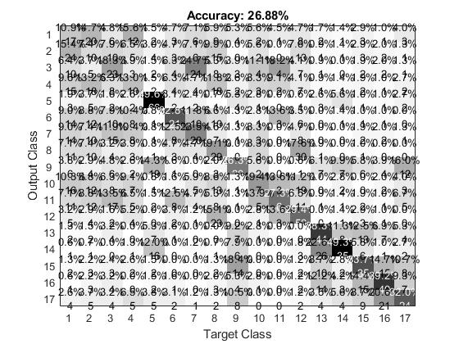

**Test Data Set**

**c. Taiji Data Set:**

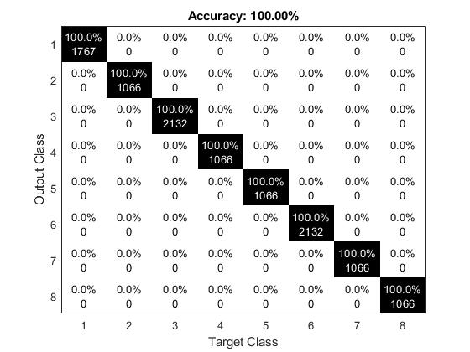

**Training Data Set**

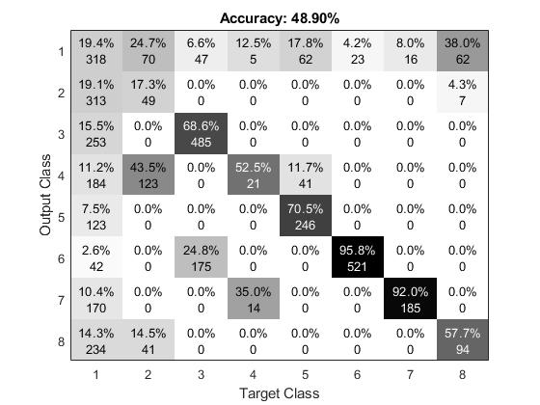

**Test Data Set**

1. **Fisher LDA as special case of Linear Regression(for 2 classes):**

Let’s say the targets for class C1 be N/N1, where N1 is the number of patterns in class C1, and N is the total number of patterns.

For class *C*2, we shall take the targets to be *-N/N*2, where *N*2 is the number of patterns in class *C*2

The sum-of-squares error function can be written:

$$E=\frac{1}{2}\sum_{1}^{N}{{\left[w^{T}x_{N}+w_{0}-t_{n}\right]}^{2}}$$

Setting the derivatives of *E* with respect to *w*0 and **w** to zero, we obtain respectively $\sum_{1}^{N}{{\left[w^{T}x_{N}+w_{0}-t_{n}\right]x_{N}}^{}}$ 
  
 = 0

making use of our choice of target coding scheme for the $t_{n}$, we obtain an expression for the bias in the form.

$ω_{0}{=-w}^{T}m$

where we have used

$$\tilde{Σ}t_{n}=N_{1}\frac{N}{N_{1}}-N_{2}\frac{N}{N_{2}}=0$$

and where **m** is the mean of the total data set and is given by:

$$M=\frac{1}{N}\left(N_{1}M_{1}+N_{2}M_{2}\right)$$

Thius we can write:

$$\left(S_{w\frac{+N_{1}N_{2}}{N}}S_{B}\right)w=N\left(M_{1}-M_{2}\right)$$

$$w∝S_{w}^{-1}\left(M_{2}-M_{1}\right)$$

**Below are the confusion matrices for wine data after removing class 3:**

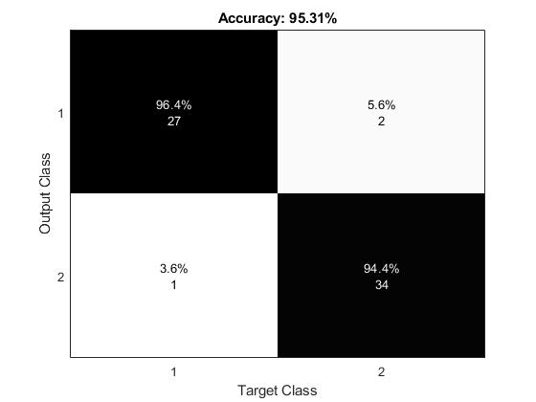

**Least Square Test Data Set**

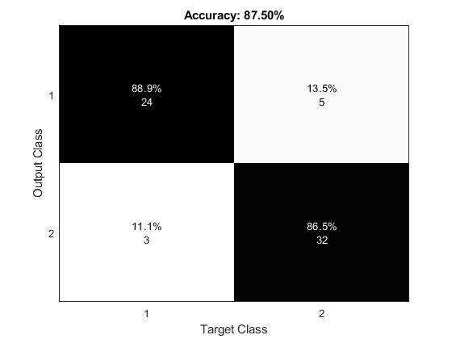

**Fisher LDA Test Data Set**